Man

Woman
THE ANGLO-SAXONS – WHO WORE WHAT?


The Answers
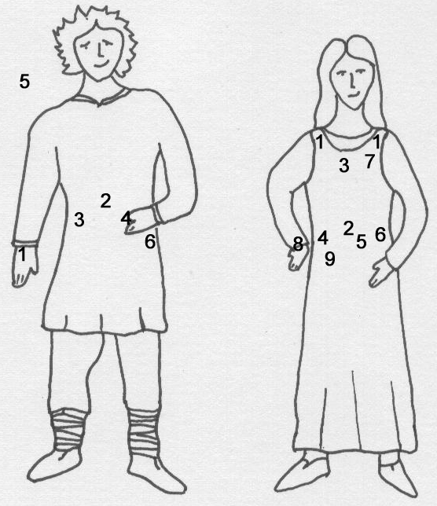
Write your answers here:

Man

1 – Finger Ring
2 – Buckle
3 – Knife
4 – Shield boss
5 – Spearhead
6 - Sword

Woman

1 – Brooches
2 – Buckle
3 – Beads
4 – Ivory Purse Ring
5 – Knife or Girdle-hanger
6 – Knife or Girdle-hanger
7 – Cloak pin
8 – Bracelet
9 – Spindle-whorl

