EXPLORE THE EVIDENCE…ANGLO-SAXON DEATH

Archaeologists and historians documents as evidence for what happened in the past.

Your task is to find out about a grave recorded by the archaeologist, Edward Thurlow Leeds.

Here is your evidence:

- Photographs of an Anglo-Saxon grave when it was excavated.
- Photographs of objects.
- Newspaper cuttings.

Use the evidence to answer these questions:

Question | Answer | What evidence did you use?
Where and when was this grave excavated?
What was the person in the grave male or female?
How old was the person?
What was the person wearing?
What was found in the grave?
What else can you find out about this burial?
EXPLORE THE EVIDENCE…ANGLO-SAXON DEATH

Newspaper Articles

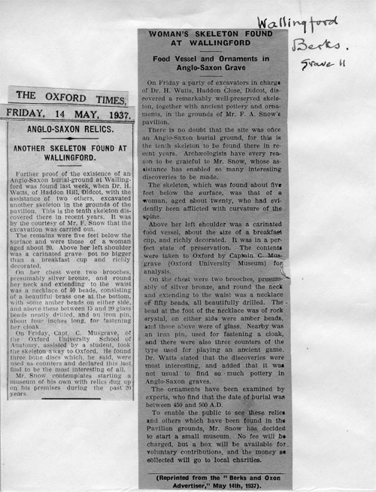
EXPLORE THE EVIDENCE…ANGLO-SAXON DEATH

Photographs (1)

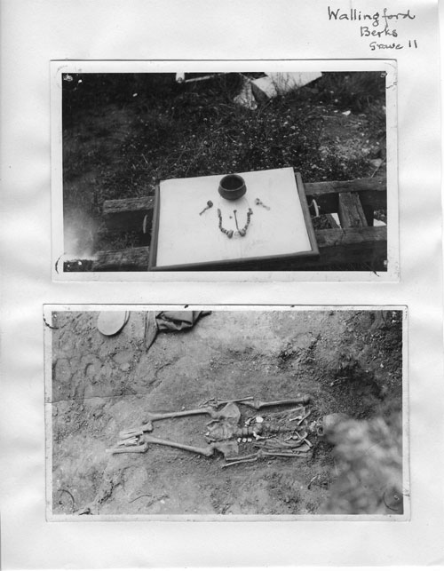
Record sheet created by Edward Thurlow Leeds
EXPLORE THE EVIDENCE…ANGLO-SAXON DEATH

Photographs (2)

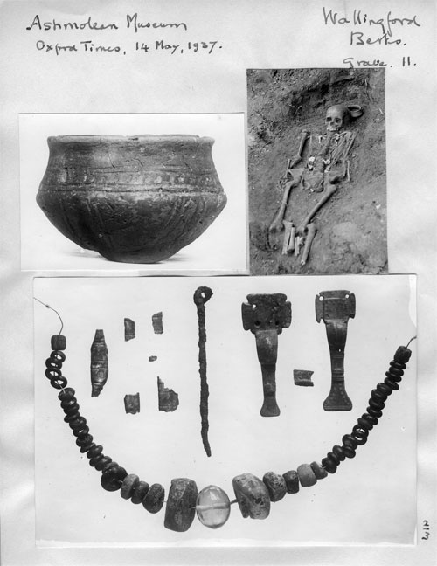
Record sheet created by Edward Thurlow Leeds
EXPLORE THE EVIDENCE…ANGLO-SAXON DEATH

Photographs (3)

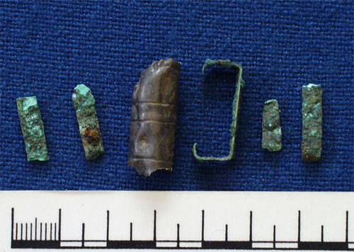

Ashmolean Museum record of objects

